Scott Courchaine

CS 499 – Capstone Enhancement

Data Structures and Algorithms

March 27, 2020

For the data structures and algorithms portion of the capstone, I have decided to improve my CS 340 final for Client/Server Development. Using the Codio environment and the previously imported json file for the market database and stocks collection, I have created a few enhancements.

To show my understanding of data structures and how documents within MongoDB can be embedded, I first accessed MongoDB for the server-side using “sudo mongod” in one terminal. For the client-side, I accessed MongoDB using “sudo mongo” in another terminal. Once connected on the client side, I accessed the market database, which can be seen below:

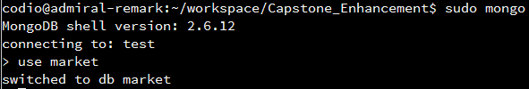

I performed a query to see the last field listed within a document, which happened to be “50-Day Simple Moving Average”. I decided to add a new field to this list called “Company Info”. This field would serve as the parent node to two other child nodes, “Date Founded” and “CEO”. “Date Founded” would serve as the parent node to two child nodes, “Month(XX)” and “Year(XXXX)”. “CEO” would serve as the parent node to two child nodes, “First Name” and “Last Name”. Using these embedded fields, I can show my understanding of how data structures work. The following image shows exactly how to add these fields to every single document within the stocks collection:



The bottom line of output shows that 6757 items were matched and the same amount of items were modified. This means that each document in the collection was updated to include the new embedded fields. Performing a find query allows me to see my results were successful:



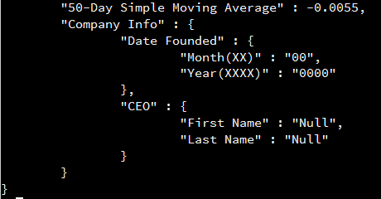

As seen above, the previous field in the last position, “50-Day Simple Moving Average”, is now followed by the new fields I have created. I can actually go a bit further in the data structure category by setting these values. To set these values for a specific document, one can use an update function while specifying a particular key/value pair. I chose to update the one document with the “Ticker” key having a value of “A”. I used this actual company of Agilent Technologies and updated the proper information to go into the system (Agilent, n.d.). This can be seen below:



The results of this update can be seen below after performing another query:

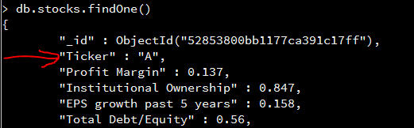

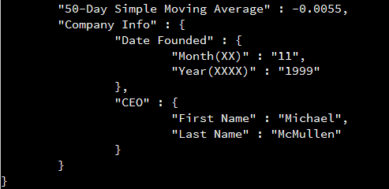

For the algorithm portion of the enhancement, I decided to use an aggregate pipeline to help display a sequence of instructions that the Codio environment must compile. For starters, I made sure I was in a terminal that was already accessing the client-side of MongoDB. Then I performed an aggregate pipeline that filtered through the 6,757 documents. I made sure that the data was sorted starting with the highest amount of EPS growth from the past five years and descending downward. I then made sure the results matched the “Utilities” sector. I then made sure the resulting documents were displayed by the ticker, the EPS growth in the past five years, and also the company name. I deactivated the id so the results would not show that field. Lastly, I limited the results to just 10. The following is an image of my pipeline and results:

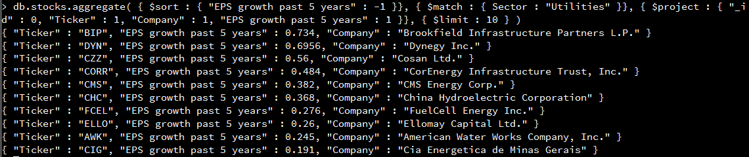

To show, how this pipeline works again, I created another example. I chose to sort the documents by the highest performance of the year to date and move in descending order. I then matched the industry to match the medical laboratories and research. I projected the results by the company, the performance year to date, and the performance measured that week. I also deactivated the id so it wouldn’t be shown in the results. Lastly, I limited these results to just 10. The following image shows the pipeline and the results:

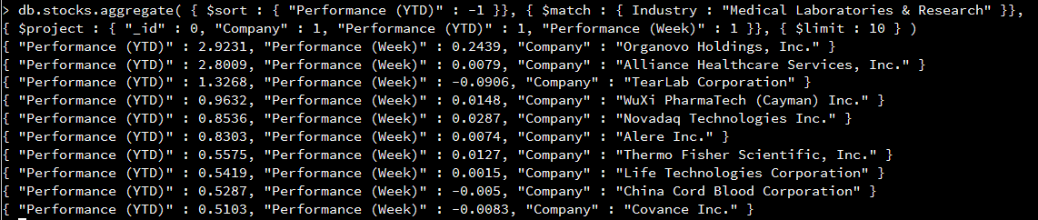

The results I have produced shows my understanding of MongoDB and how to utilize data structures and algorithms to solve particular issues. These activities have proven to be a success in enhancing my project, while sharing my skills and displaying my comprehension of the material.

Source:

“Company History” (n.d.). *Agilent*. Retrieved on March 27, 2020 from <https://www.agilent.com/about/companyinfo/history/>.